Calculate Channel Financial Metrics (AOV, PF, CLTV)
Computes Average Order Value (AOV), Purchase Frequency (PF), and Historical CLTV per channel.

QUERY-;
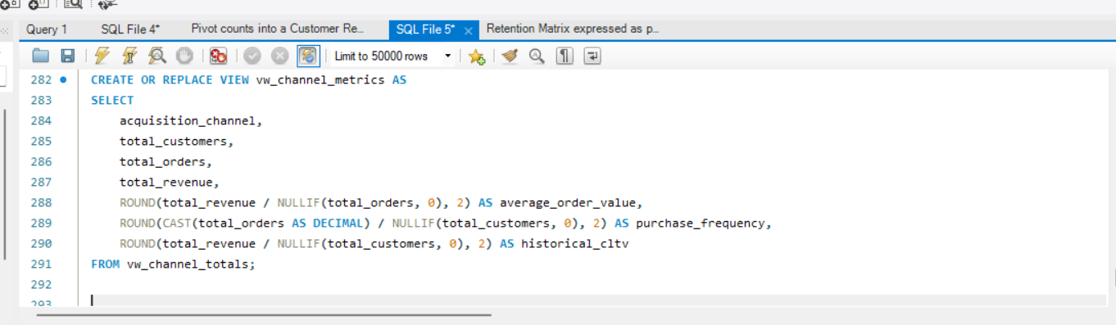

OUTPUT-;

